

Compensation and Pension Record Interchange (CAPRI)

DVBA*2.7*123 Release Notes

October 2008

Department of Veterans Affairs
Office of Enterprise Development (OED)

Table of Contents

Introduction 2
General CAPRI Functionality Changes 3
C&P Worksheet Tab Changes 5

Introduction

The purpose of this release notes document is to outline the changes made to the Compensation and Pension Records Interchange (CAPRI) software in patch DVBA*2.7*123 and CAPRI Graphical User Interface (GUI) v123. Patch DVBA*2.7*123 is the Vista server-side patch needed to support the CAPRI GUI v123, therefore, DVBA*2.7*123 should be installed on your VistA system before using CAPRI GUI v123. This document provides an overview of the functionality that will be provided with this software release.

General CAPRI Functionality Changes

Description of Change | Details
Users will no longer have the ability to Close/Quit/Exit the CAPRI GUI application if they have a template open.  The purpose of this modification is to prevent a user from inadvertently exiting the CAPRI application without saving their work on an open template. | If a user has a template open and attempts to Close/Quit/Exit the CAPRI application, CAPRI will display a message to the user “Please close the open Template.”  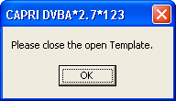
A simplified patient entry screen will be available in CAPRI for use by the Suicide Prevention team.  The purpose of this modification is to simplify the entry of a new patient into VistA through the CAPRI GUI.  Users in remote mode and users on the CLAIMS system can be assigned security key DVBA CAPRI SIMPLE PT ENTRY in order to exercise the simplified patient entry functionality.  Note: Security key DVBA CAPRI SIMPLE PT ENTRY will not be available on local sites. | The fields required to complete the simplified patient entry are First Name, Last Name, Gender, DOB, Patient Type, Veteran?, and Service Connected?.  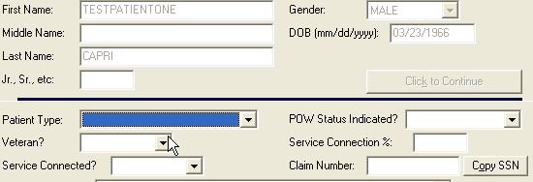  The Address, Addr2, Addr3, City, State, Zip+4, Phone, Office Phone, and County fields are available on the simplified patient entry screen, but not required to complete this type of patient entry via CAPRI.

Technical enhancements have been made to the CAPRI application to allow the CAPRI GUI application to run using the new Broker Security Enhancement (BSE) software. The BSE project was released in patches XWB*1.1*45 and XU*8.0*404. | With the M side patch for version 123 of CAPRI, one new entry named "CAPRI" has been added to the REMOTE APPLICATION (#8994.5) file in VistA. This will allow the CAPRI GUI application to run using the new Broker Security Enhancement (BSE) software. This new BSE-based mechanism will subsequently replace the current CAPRI-based mechanism for remote user/visitor access by RPC Broker Delphi-based client/server applications.  The CAPRI application allows Veterans Benefits Administration (VBA) staff to remotely access VistA data related to claims for veterans treated at any VistA site. The purpose of these technical enhancements is to fulfill the requirement for allowing VBA users to have secure access to patient information at remote sites.

C&P Worksheet Tab Changes

Description of Change | Details
The functionality for deleting a template has been modified.  The purpose of this modification is to prevent users from inadvertently deleting templates.  Users will now be required to enter a verification code when attempting to delete a template to ensure the deletion is the intended action.  Additionally, the Delete button on the C&P Worksheets tab has been moved away from the Copy, Display, and Refresh buttons to prevent users from accidentally selecting Delete. | On the unsigned templates dialog and C&P Worksheets tab, when delete is clicked or selected from the keyboard, CAPRI will now prompt the user to enter a system generated verification code before completing the deletion process. If the verification code is not entered correctly or cancel is selected, the template deletion will not be completed.  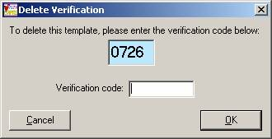  The Delete button on the C&P Worksheets tab has been moved away from the Copy, Display, and Refresh buttons to prevent users from accidentally selecting Delete.  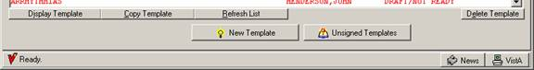

The CAPRI GUI - CPWM has been enhanced to allow an end-user to set the color of buttons on a template. The color of the button will then be maintained between sessions.  The purpose of this modification is to allow CAPRI power users to mark certain template sections (i.e. buttons) with a color if they need to come back to them.  The color of the button will then be maintained between sessions. This will let power users mark certain template sections (i.e. buttons) if they need to come back to them. For example, exam reviewers could flag template sections for a user to review. | A user may change the color of a button within a template by right-clicking the button and selecting a color from the pop-up menu.  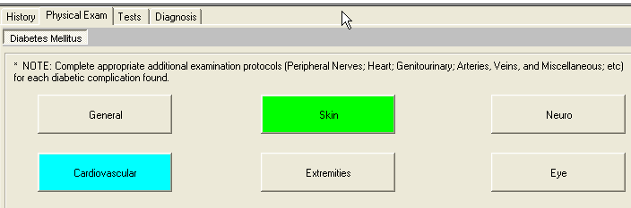
Technical enhancements have been made to the CAPRI GUI - CPWM module and to the individual templates that are accessible through the C&P Worksheets tab.  The purpose of this modification is to improve the response time when clicking on template controls. Additionally, users should notice improved performance when loading individual and merged templates. | The CAPRI GUI has been modified to support the use of a Pascal Scripting engine. The Pascal Script engine allows event procedures to be associated with screen objects (i.e. Buttons) on template forms. The Pascal Script (i.e. event procedures) performs the work when a screen object is clicked or changed on a template form. The engine also allows functions, procedures, and variables from the CAPRI GUI application to be imported and used within the template script, providing a more robust development environment for template developers. This is a vast improvement over the scripting language that was used previously for template development. Since the script is now event based and compiled, it executes faster than the previous template script, providing improved performance to end-users.  Additionally, all (58) of the current CAPRI templates have been re-scripted using the Pascal programming syntax.

